Marketing Simulation Report Template
BY 6681224 Nathan Tanaboriboon
Part 1: Results & Screenshots

Screenshot of final bag design (insert below)
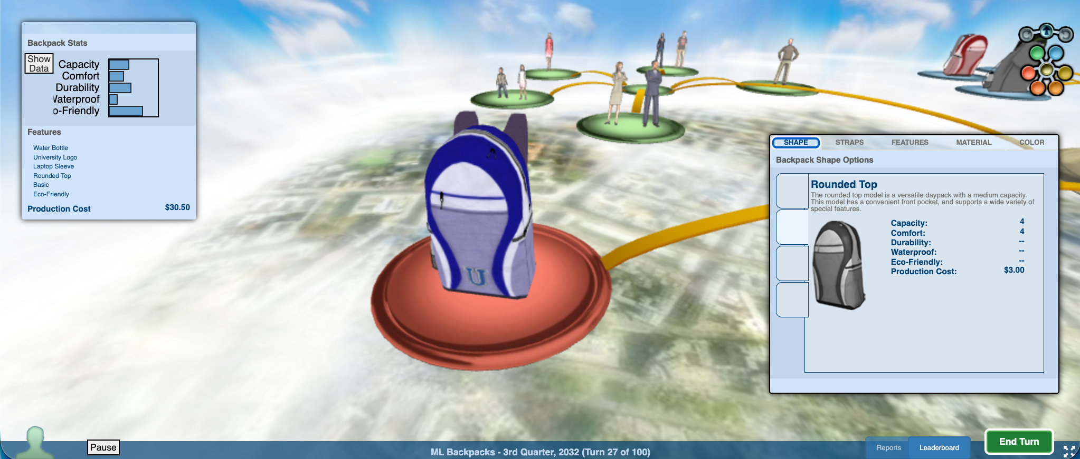

Screenshot of KPIs net profit, bank balance, market share (insert below)
(first two photos are from first round of playing, I closed my laptop lid so my progress was all gone, so I did play for the second time with the learned and improved strategy, so that is why second round looks static in terms of marketing strategy change.
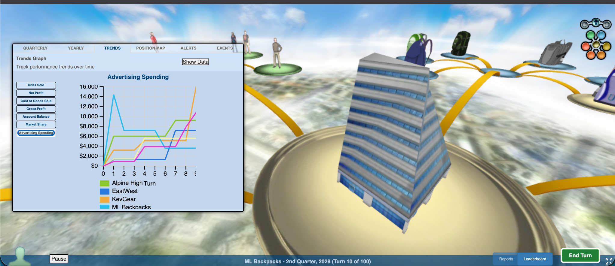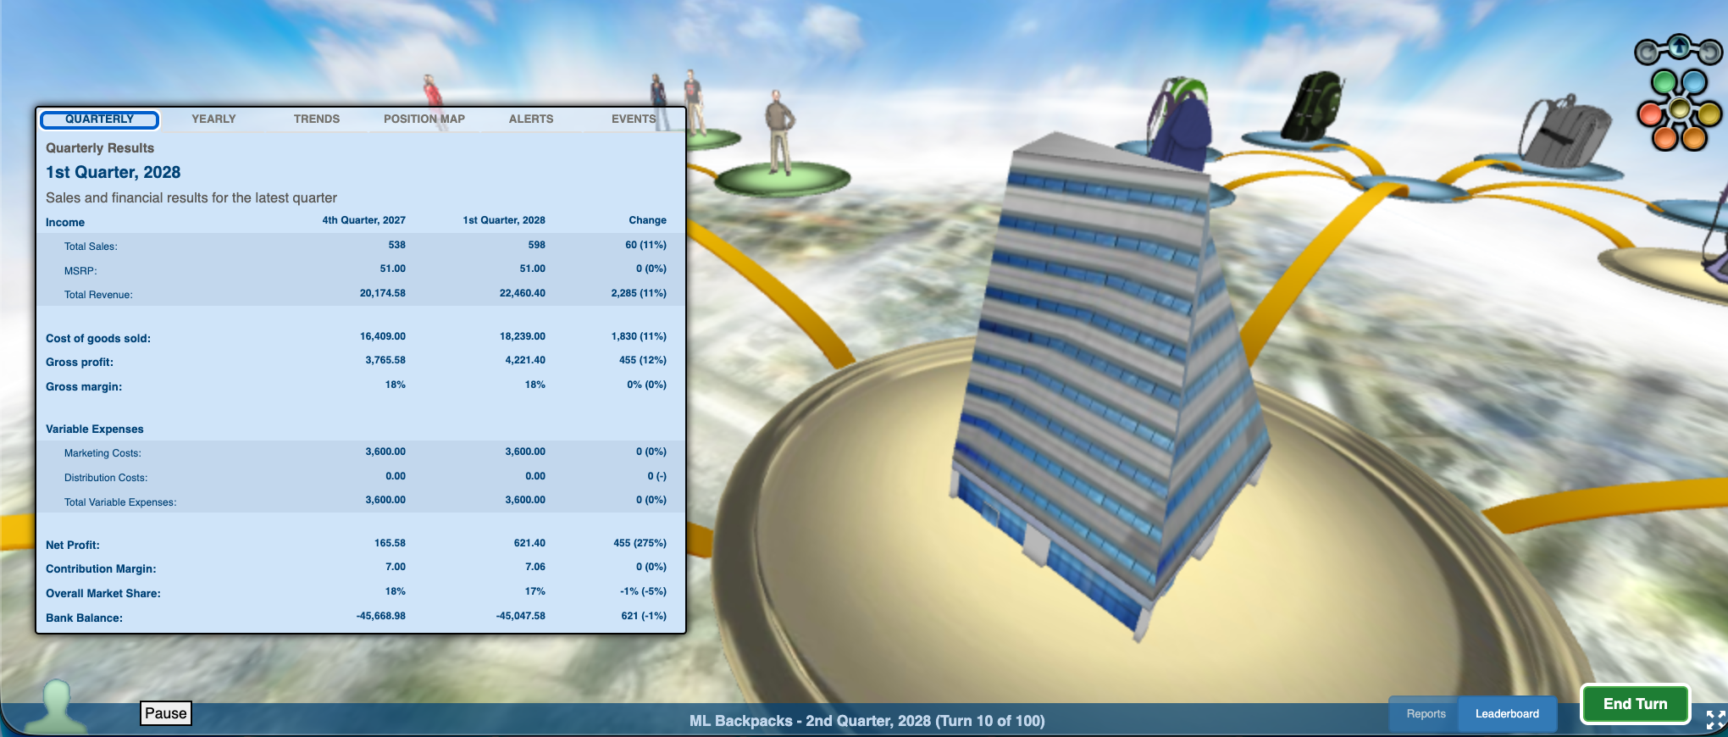
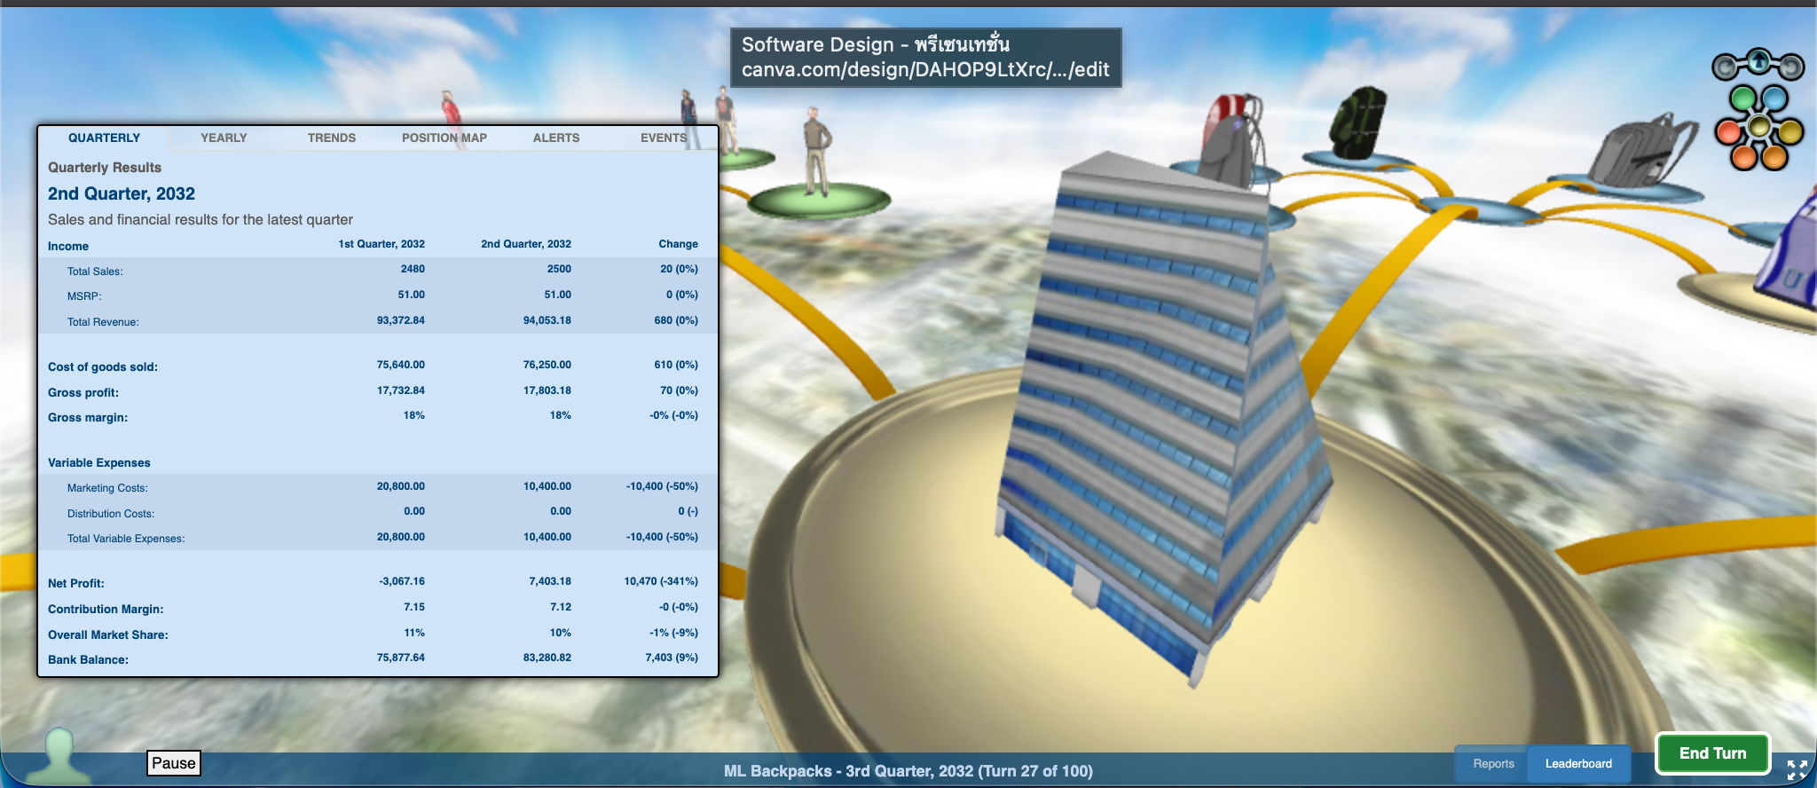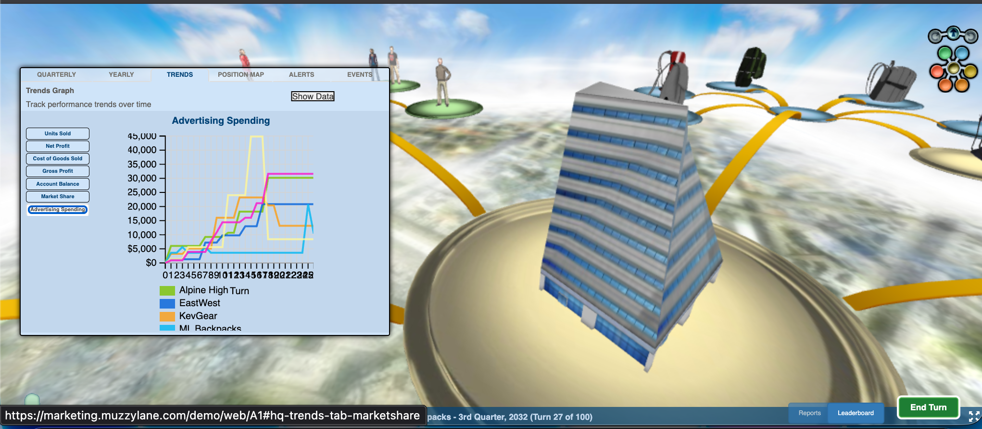

Part 2: Marketing Strategy

2.1 Target Market Rationale

Who was your target customer? Provide data to support your decision (e.g., segment size, needs)

University students, because mainly of couple of reasons. First, their segment size is the second largest, just below children, but their purchasing power is higher than those of the children. Second is their bag preference is very clear, that they need a bag that is eco-friendly, thus it marks a clear concept of product.

2.2 Positioning & Strategy

What positioning did you choose? (e.g., premium, value, trendy) What made your product different?

Great value and fashionable. It is a positioning that is unique, since the other bag, either becomes cheap, utilitarian, or become an expensive luxurious bag, but the market in the middle is never explored. A bag which can be utilitarian, functional, although comes with small but noticeable trace of styles, like university emblem and color.

2.3 Marketing Mix Decisions
Summarize your marketing mix decisions:
Marketing Mix Element | Your Decision |  | Your Justification (link to segment needs/concepts)
Product |  | Eco-friendly backpack with specifically requested features (water bottle holder, laptop sleeve, and university emblem). With blue color which students like (tried many times to get the color right) |  | Directly answering to customer’s feedback and preferences. It is already mentioned in student’s preference that they value eco-friendly product. Colors were changed many times and blue yielded the best satisfaction. Other features were chosen the same way,
Price |  | $51.00 |  | Customer feedback indicated this was "High, but still in my budget." It maximized gross margins per unit while keeping High-End retail channels open (avoiding the penalty of pricing too low).
Place |  | Multi-channel including High-End Stores and University Stores. |  | Placed the product directly in the students’ typical shopping environments. Maintaining the $51 price point was crucial to keep the High-End store distribution. High end store was chosen due to their third largest in students-as-customer size, just right after university store and direct.
Promotion |  | Variable spending (avg. $3,600, peaking at ~$11,000 late game) heavily focused on Social Media and Top 40 Radio. |  | Percentage is clear, these two channels have the largest percentage (or second largest) of students as their customers. Choosing them as a marketing channel would allow us to sell the product directly to them.

Part 3: Reflection & Lessons Learned

What did you learn about marketing strategy from this simulation?

I have learned about how marketing strategy can be planned to yield the best outcome, in terms of market share, net profits, bank balance, and sales. I learn that one of the best way to grab a large market share in the first place, is to advertise heavily then tone it down later (and increase it in certain quarters). Then, focus on single target group, to strengthen brand image and to put all the focus to be on single customer segment, allowing a fast market dominance over that customer segment. The product attributes also have to revolve around what the target customers want (eco-friendly, righr color, university emblem for example), with the price to be high but not exceed the acceptable range to maximize profit, and in order to keep distribution channels profit as well (if we cannot generate them enough profits, sales would drop drastically) and do not heavily invest in everything for a long run or else the company would just go bankrupt.

How has your thinking about consumer behavior, competition, and strategy changed?

I learn a lot more about factors related to marketing, that marketing is concerned also about how promotion, price, place, and people are considered together, all at the same time, that it is not about product only, but also about other factors as well. Good product can be hard to sell with false advertisement and distribution channel. The game also taught me that in the world of business, initial loss is somewhat destined to happen, this is a new paradigm shift for me because I understood that business is supposed to generate revenue, profits, but this intial loss that I discovered through game, that it was required to happen both times that I played the game was done to secure a large enough customer base. It has been fun playing it, although somewhat stressful as well.

What would you do differently if you restarted the simulation?
I would decrease my aggressiveness in terms of investment in multiple factors, such as, promotion (media) and investment and discount in distribution channel, and be brave enough to try different distribution channel when there seems to be no reason for continuous loss of the profit (I didn’t expect then problem to come from distribution channel, I changed it and the loss was stopped, quarters after becomes profitable right away.)

